Step 1 - Setup Java Development Kit (JDK)

You can download the latest version of Java JDK from Oracle's Java site: [Java SE Downloads](http://www.oracle.com/technetwork/java/javase/downloads/index.html). You will find instructions for installing JDK in downloaded files, follow the given instructions to install and configure the setup. Finally set PATH and JAVA_HOME environment variables to refer to the directory that contains **java** and **javac**, typically java_install_dir/bin and java_install_dir respectively.

If you are running Windows and installed the JDK in C:\jdk1.6.0_15, you would have to put the following line in your C:\autoexec.bat file.

set PATH=C:\jdk1.6.0_15\bin;%PATH%

set JAVA_HOME=C:\jdk1.6.0_15

Alternatively, you could also right-click on *My Computer*, select *Properties*, then *Advanced*, then*Environment Variables*. Then, you would update the PATH value and press the OK button.

On Linux, if the SDK is installed in /usr/local/jdk1.6.0_15 and you use the C shell, you would put the following code into your **.cshrc** file.

setenv PATH /usr/local/jdk1.6.0_15/bin:$PATH

setenv JAVA_HOME /usr/local/jdk1.6.0_15

Alternatively, if you use an Integrated Development Environment (IDE) Eclipse, then it will know automatically where you have installed your Java.

Step 2 - Setup Android SDK

You can download the latest version of Android SDK from Android official website : [Android SDK Downloads](http://developer.android.com/sdk/index.html). If you are installing SDK on Windows machine, then you will find a *installer_rXX-windows.exe*, so just download and run this exe which will launch *Android SDK Tool Setup* wizard to guide you throughout of the installation, so just follow the instructions carefully. Finally you will have*Android SDK Tools* installed on your machine.

If you are installing SDK either on Mac OS or Linux, check the instructions provided along with the downloaded *android-sdk_rXX-macosx.zip* file for Mac OS and *android-sdk_rXX-linux.tgz* file for Linux. This tutorial will consider that you are going to setup your environment on Windows machine having Windows 7 operating system.

So let's launch *Android SDK Manager* using the option **All Programs > Android SDK Tools > SDK Manager**, this will give you following window:

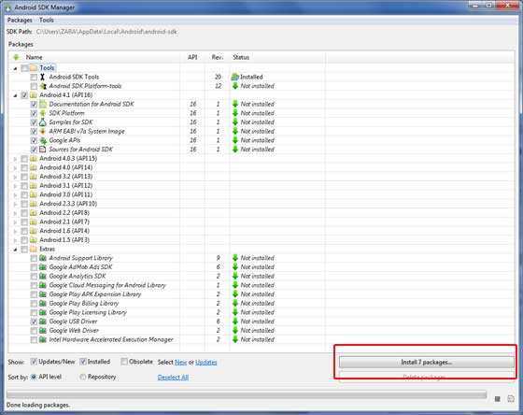

Once you launched SDK manager, its time to install other required packages. By default it will list down total 7 packages to be installed, but I will suggest to de-select *Documentation for Android SDK* and*Samples for SDK* packages to reduce installation time. Next click **Install 7 Packages** button to proceed, which will display following dialogue box:

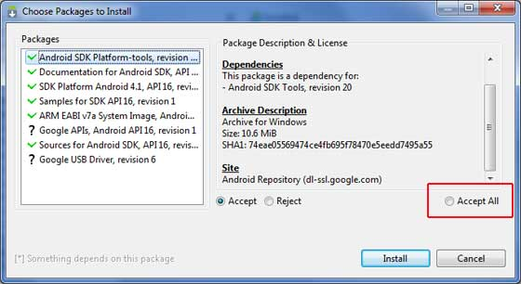

If you agree to install all the packages, select **Accept All** radio button and proceed by clicking **Install**button. Now let SDK manager do its work and you go, pick up a cup of coffee and wait until all the packages are installed. It may take some time depending on your internet connection. Once all the packages are installed, you can close SDK manager

using top-right cross button.

Step 3 - Setup Eclipse IDE

All the examples in this tutorial have been written using Eclipse IDE. So I would suggest you should have latest version of Eclipse installed on your machine.To install Eclipse IDE, download the latest Eclipse binaries from <http://www.eclipse.org/downloads/>. Once you downloaded the installation, unpack the binary distribution into a convenient location. For example in C:\eclipse on windows, or /usr/local/eclipse on Linux and finally set PATH variable appropriately.Eclipse can be started by executing the following commands on windows machine, or you can simply double click on eclipse.exe

%C:\eclipse\eclipse.exe

Eclipse can be started by executing the following commands on Linux machine:

$/usr/local/eclipse/eclipse

After a successful startup, if everything is fine then it should display following result:

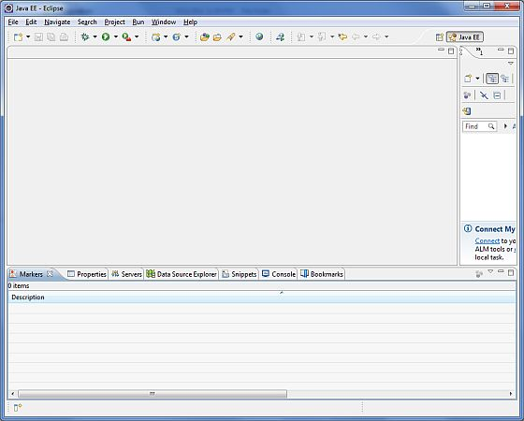

Step 4 - Setup Android Development Tools (ADT) Plugin

This step will help you in setting Android Development Tool plugin for Eclipse. Let's start with launching Eclipse and then, choose **Help > Software Updates > Install New Software**. This will display the following dialogue box.

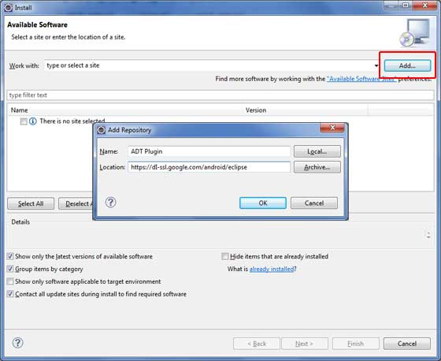

Now use **Add** button to add *ADT Plugin* as name and *https://dl-ssl.google.com/android/eclipse/* as the location. Then click OK to add this location, as soon as you will click OK button to add this location, Eclipse starts searching for the plug-in available the given location and finally lists down the found plugins.

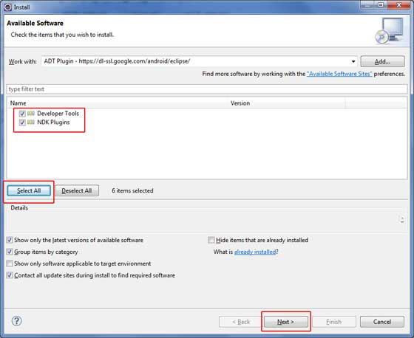

Now select all the listed plug-ins using **Select All** button and click **Next** button which will guide you ahead to install Android Development Tools and other required plugins.

Step 5 - Create Android Virtual Device

To test your Android applications you will need a virtual Android device. So before we start writing our code, let us create an Android virtual device. Launch Android AVD Manager using Eclipse menu options**Window > AVD Manager>** which will launch Android AVD Manager. Use **New** button to create a new Android Virtual Device and enter the following information, before clicking **Create AVD** button.

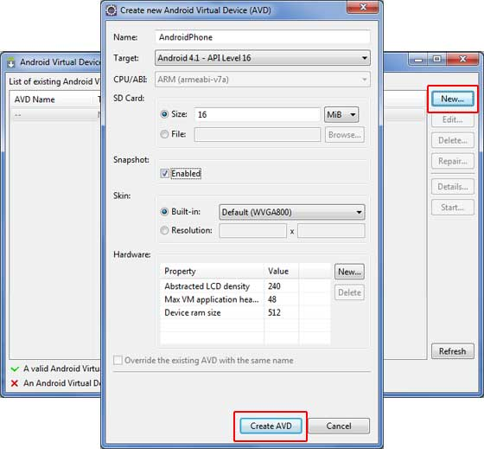

If your AVD is created successfully it means your environment is ready for Android application development. If you like, you can close this window using top-right cross button. Better you re-start your machine and once you are done with this last step, you are ready to proceed for your first Android example but before that we will see few more important concepts related to Android Application Development.